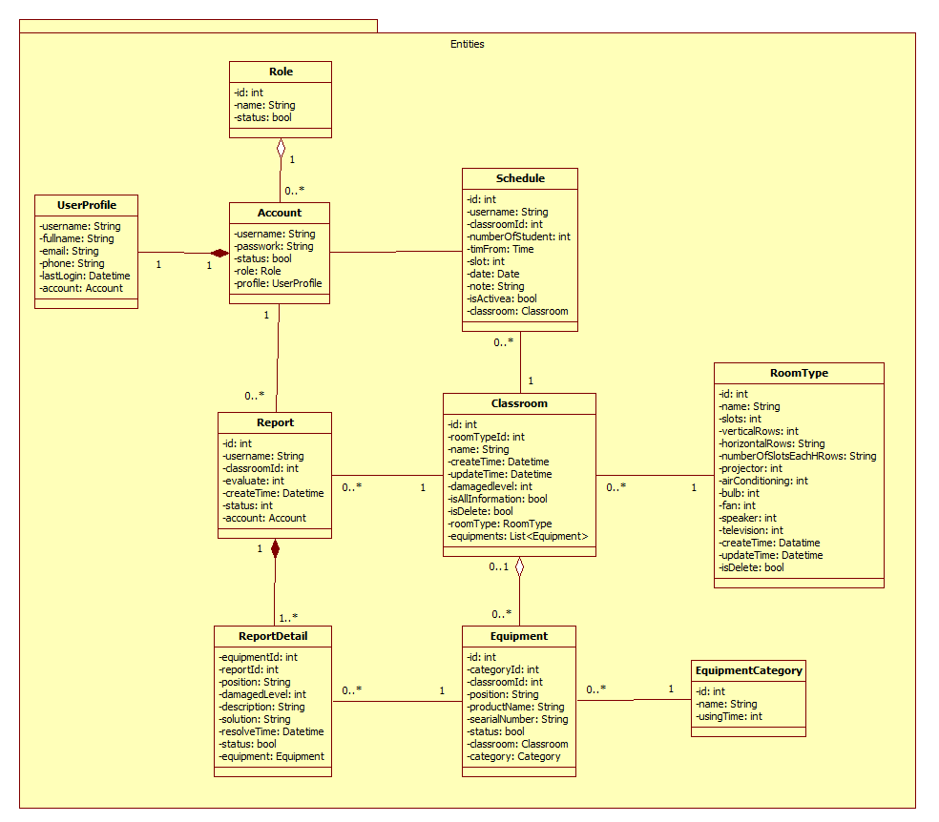

***Role***

|  |  |  |  |
| --- | --- | --- | --- |
| Attribute | Type | Visibility | Description |
| id | int | Private | Unique identifier of role |
| name | String | Private | Name of role |
| status | bool | Private | Status will define for active role or deactivate role. |

***UserProfile***

|  |  |  |  |
| --- | --- | --- | --- |
| Attribute | Type | Visibility | Description |
| username | String | Private | Unique identifier of profile |
| fullname | String | Private | The full name’s account |
| email | String | Private | The user’s email |
| phone | String | Private | The user’s phone |
| lastLogin | String | Private | User login to system in last time |
| account | Account | Private | Account’s profile |

***Account***

|  |  |  |  |
| --- | --- | --- | --- |
| Attribute | Type | Visibility | Description |
| username | String | Private | Unique identifier of account |
| password | String | Private | The user’s password |
| Status | bool | Private | The user’s status |
| role | Role | Private | The user’s role |
| profile | Userprofile | Private | The user’s profile |

***Report***

|  |  |  |  |
| --- | --- | --- | --- |
| Attribute | Type | Visibility | Description |
| id | String | Private | Unique identifier of account |
| username | String | Private | The username who create report |
| classroomId | int | Private | Classroom’s id which was created report |
| evaluate | String | Private | The user’s evaluate |
| createTime | Datetime | Private | The report’s create date |
| Status | int | Private | The report’s status |
| account | Account | Private | Account create report |

***ReportDetail***

|  |  |  |  |
| --- | --- | --- | --- |
| Attribute | Type | Visibility | Description |
| equipmentId | int | Private | The damaged equipment’s id |
| reportId | int | Private | The report’s id |
| position | String | Private | The position of equipment in room |
| damagedLevel | int | Private | The user evaluate damaged equipment |
| description | String | Private | The damaged equipment’s description |
| solution | String | Private | The solution of staff who fix equipment |
| resolveTime | Datetime | Private | The time of resolve |
| Status | bool | Private | The report detail’s status |
| equipment | Equipment | Private | The damaged equipment |

***EquipmentCategory***

|  |  |  |  |
| --- | --- | --- | --- |
| Attribute | Type | Visibility | Description |
| id | int | Private | Unique identifier of category |
| name | String | Private | The equipment’s name |
| status | bool | Private | The category’s status |

***Equipment***

|  |  |  |  |
| --- | --- | --- | --- |
| Attribute | Type | Visibility | Description |
| id | int | Private | Unique identifier of equipment |
| categoryId | int | Private | The category’s id |
| classroomId | int | Private | The classroom’s id |
| position | String | Private | The equipment’s position |
| productName | String | Private | The equipment’s product name |
| serialNumber | String | Private | The equipment’s serial number |
| Status | bool | Private | The equipment’s status |
| classroom | Classroom | Private | The equipment’s classroom |
| category | EquipmentCategory | Private | The equipment’s category |

***Classroom***

|  |  |  |  |
| --- | --- | --- | --- |
| Attribute | Type | Visibility | Description |
| id | int | Private | Unique identifier of classroom |
| roomTypeId | int | Private | The roomtype’s id |
| name | String | Private | The classroom’s name |
| createTime | Datetime | Private | The room was created in this date |
| updateTime | Datetime | Private | The room was updated in this date |
| isAllInformation | bool | Private | Check complete room’s information |
| isDelete | bool | Private | Check active or deactivate room |
| roomType | RoomType | Private | The classroom’s type |
| equipment | List<Equipment> | Private | The list equipment in the room |

***Schedule***

|  |  |  |  |
| --- | --- | --- | --- |
| Attribute | Type | Visibility | Description |
| id | int | Private | Unique identifier of schedule |
| username | String | Private | The teacher’s username |
| classroomId | int | Private | The classroom’s id |
| numberOfStudent | int | Private | The number of student in room |
| timeFrom | Time | Private | The start time of schedule |
| slot | int | Private | The time for teacher can use |
| date | Date | Private | The date is schedule active |
| note | String | Private | The schedule’s note |
| isActive | bool | Private | The schedule’s status |
| classroom | Classroom | Private | The classroom was used |

***Roomtype***

|  |  |  |  |
| --- | --- | --- | --- |
| Attribute | Type | Visibility | Description |
| id | int | Private | Unique identifier of schedule |
| name | String | Private | The teacher’s username |
| slots | int | Private | The number of student in the room type |
| verticalRows | int | Private | The number of row in the room type |
| horizontalRows | String | Private | The number of horizontal row in vertical row |
| numberOfSlotsEachHRows | String | Private | The number of chair in horizontal row |
| projector | int | Private | The number of projector in room type |
| airConditioning | int | Private | The number of air conditioning in the room type |
| bulb | int | Private | The number of bulb in the room type |
| fan | int | Private | The number of fan in the room type |
| Speaker | int | Private | The number of speaker in the room type |
| Television | int | Private | The number of television in the room type |
| createTime | Datetime | Private | The room type was created in this date |
| updateTime | Datetime | Private | The room type was created in this date |
| isDelete | bool | Private | Check active or deactivate room type |